Qtr: Autumn 2015

Class: CSC212

Professor: Dr. Julian Achim

Programmer: Odiscious Dozier

Date: 10/22/2015

In this assignment, I wanted to build a scalable solution that utilizes and meets the requirements stated in the Case 03 Assignment. I extended my JPanelDemo class with the JFrame class and also implemented the ActionListener interface. I went to the lengths of implementing the interface because, I wanted to add an event listener to the button; therefore, when it’s clicked the input text box will clear data and the user’s eye will naturally flow to the text box that shows the result. I built the functionality, of course.

While polymorphism is not the primary focus here, I did utilize the super class (JFrame) constructor and added the event listener to this object.

Additionally, I wanted to show the use of an array. I did not loop through the array or sort the data with any known sorting algorthim, quicksort(), mergeSort(), or insertSort().

The resultant program is pretty straight forward, but is certainly not tested for all use cases. Instead, I’ve documented that all input is expected to be proper and it passes functional tests only. With my current knowledge, I consider this one level deeper than that which is necessary for creating a prototype.

SCREEN SHOTS

Starting the Program

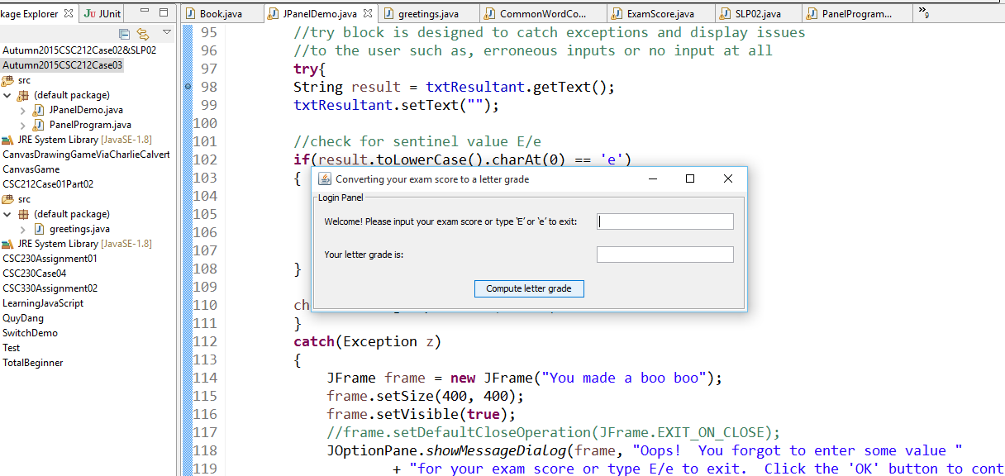

Entering valid data of Exam Score at 88%

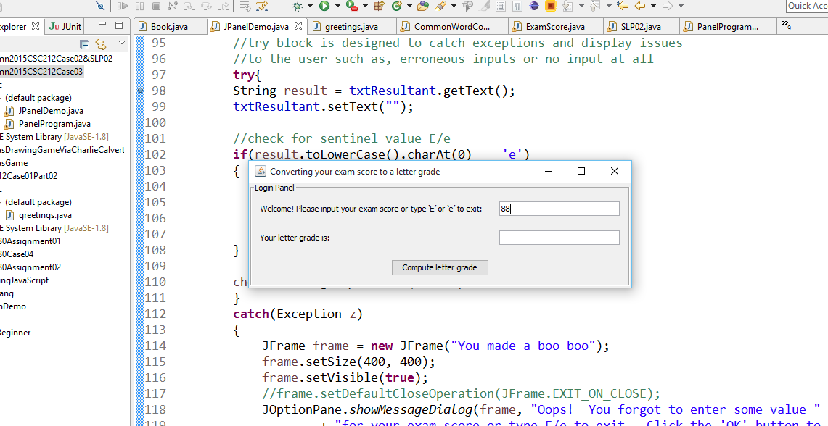

Computing Letter Grade for 88%

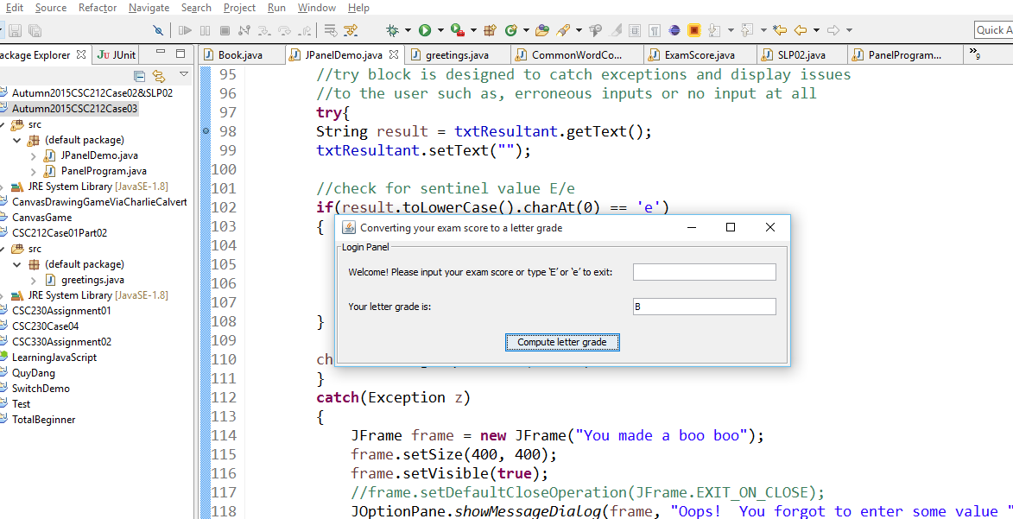

Now clicking the button with no data in the input field

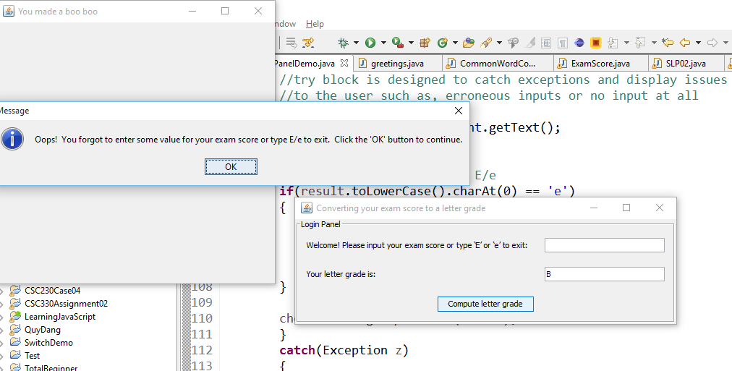

After clicking ‘OK’ in the dialog box – bad data 🡪’F’ and ready for more input (user did not select E/e)

Also, typed in e (preparing to exit program, but did not hit the button)

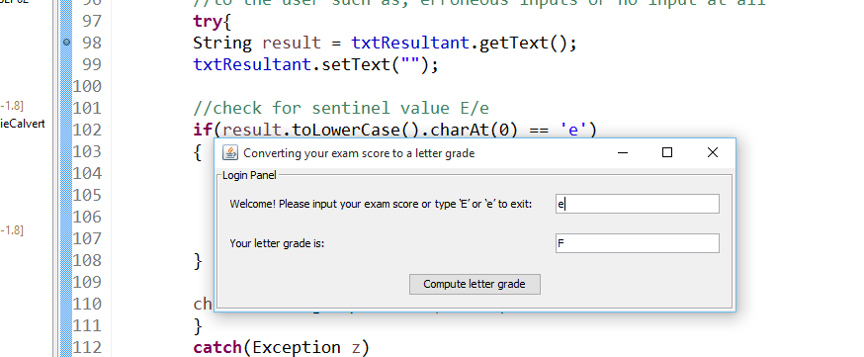

Exiting the program by clicking the button with ‘e’ in the input field

Note: The Frame is no longer active and therefore, there is nothing to show (image is of eclipse and exposed code)

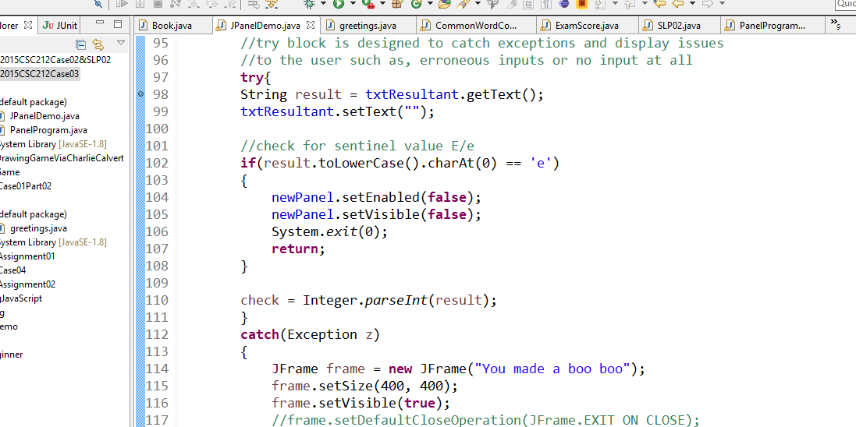

REFERENCES

Introduction to Event Listeners. (2015). Retrieved October 22, 2015, from https://docs.oracle.com/javase/tutorial/uiswing/events/intro.html

Programmatically close a JPanel which is displayed in JDialog. (2015). Retrieved October 22, 2015, from [http://stackoverflow.com/questions/10936306/programmatically-close-a- jpanel-which-is-](http://stackoverflow.com/questions/10936306/programmatically-close-a-%09jpanel-which-is-)displayed-in-jdialog